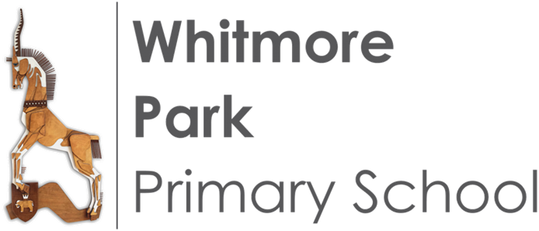
Casual Lunchtime Supervisors
Vacancies

School Name:  Whitmore Park Primary School | Casual Lunchtime Supervisory Assistants  We are looking to appoint an enthusiastic and dedicated Casual Lunchtime Supervisory Assistants to join our team. You will be required to work as part of our team to cover staff absence, supervising pupils during the lunch break, ensuring a safe environment where their developmental and welfare needs are met.  You need to be physically fit and be able to interact with all pupils in the school, encouraging play and inclusion.  Do you have:  - Experience of working with children and managing behaviour?  - The ability to work as part of a team, building relationships with children and staff?  - A caring nature, able to support the emotional wellbeing of children?  We are committed to safeguarding and promoting the welfare of all pupils and expect all staff to share this commitment. An enhanced DBS is needed for these posts.  Two references will be taken up for all short-listed candidates prior to interview.  Following recommendations from Keeping Children Safe in  Education (KCSIE) for an additional pre-employment check with  effect 1 Sept 22, please note, an online search may form part of  this recruitment process.  Applications packs are available by emailing admin@whitmorepark.org or call in to the School Office.  Completed applications can be emailed to jobs@whitmorepark.org, or handed in at the School Office or posted to the school for the attention of Mrs Christine Clough, School Business Manager.
Full Address:
Halford Lane
Keresley
Coventry
CV6 2HG
Telephone Number:
02476 335697
Email Address: jobs@whitmorepark.org
Job Title: Casual Lunchtime Supervisory Assistants
Salary range: Grade 1
£13.27 per hour
Hours:
Casual: As and when required for cover on a timesheet basis during the lunchtime period between 11.20am-1.35pm during term-time only.
Closing date:
Midnight Tuesday 29th October
Interview date:
Week commencing 1st November
Start Date: As soon as possible.

